Program Performance Lab

Student ID _____________________
Student Name _____________________
Start Time ________________________
Finish Time ________________________

Practice 1. Optimizing Analysis
About program using trigrams:
Let's look at a more complicated example. We will start with a program that was written to compute nonsense sentences using trigrams. The following sentence is an example of its output:
The man pulled out his free hand while he reeled as though debating with himself. Then he turned his head back as though the water and made him go limping grotesquely and lurching forward with stammering gait up the slope to the river.
You can see that this is neither completely random nor does it make sense. How can a computer generate sentences like this? The program starts with real English text. It reads all sequences of three consecutive words, called trigrams. The output is initialized with two words. The output is then extended by looking at the last two words, finding trigrams that start with these two words, and then picking one of the trigrams to provide a third word. Suppose, for example, that the input is the following:
This is an example. The bird is an eagle. The boy is an expert.
The trigrams are: [This is an], [is an example.], [an example. The], [example. The bird], [The bird is], [bird is an], [is an eagle], [an eagle. The], [eagle. The boy], [The boy is], [boy is an], [is an expert.], [and expert. This], and [expert. This is]. Somewhat arbitrarily, I decided to wrap around from the end to the beginning to obtain the last two trigrams.
Now let's generate some text with these trigrams. Start with two words from the original sequence: [The bird]. Now, find all the trigrams that start with [The bird]: the only one is [The bird is], so we add [is] to the sequence to get [The bird is]. Now the last two words are [bird is], which only matches [bird is an], so we add [an] to get [The bird is an].
Things get a little more interesting now. The last two words, [is an], match three trigrams: [is an eagle], [is an example], and [is an expert]. We randomly pick the third of these trigrams and extend the output with [expert] to get [The bird is an expert.] Continuing in this fashion, we might generate something like [The bird is an expert. This is an eagle. The boy is an example.] Okay, it's not too poetic, but with a much larger input, there are many more possibilities and consequently more interesting output. In addition to generating amusing output, trigram models (and generalized N-gram models) have applications in speech recognition and data compression.
Your task:
I wrote two programs to implement this text generation scheme. The program's text (words.cpp) , the revised code (words3.cpp) . Compare these two programs' performance, and write a report for the optimizing analysis.
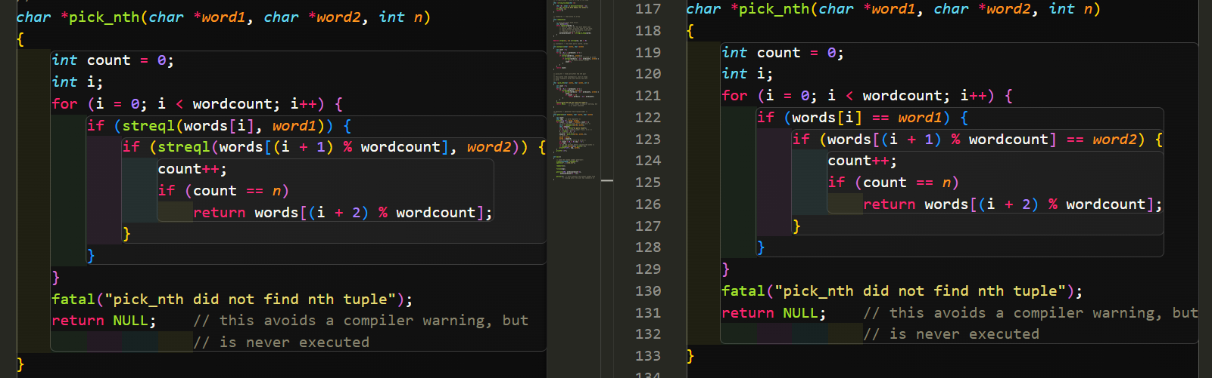
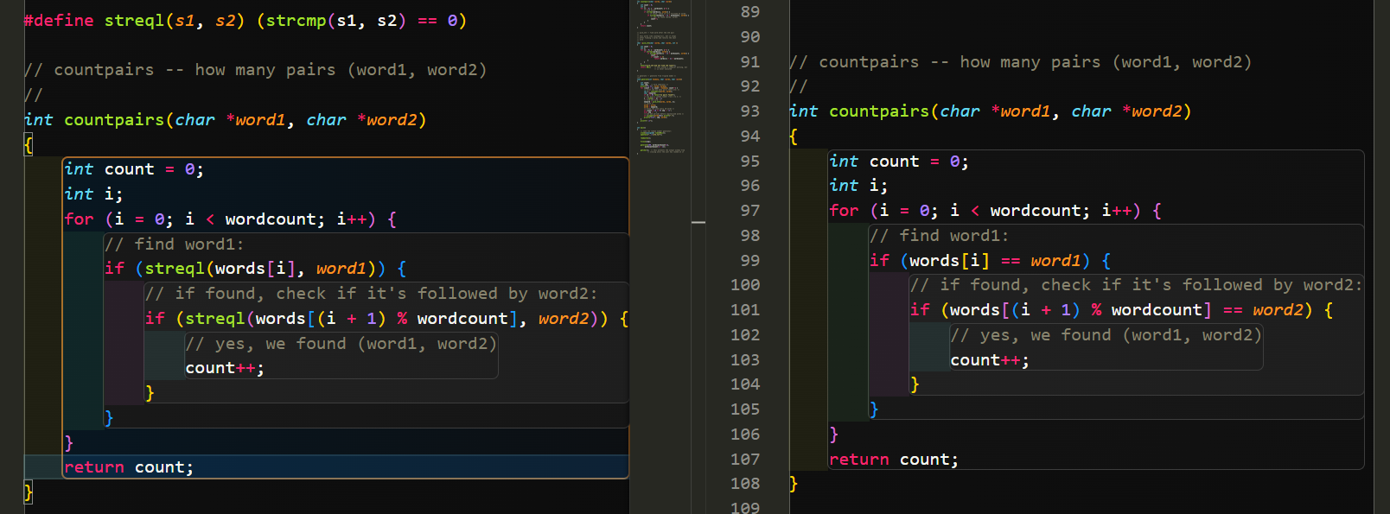
word.cpp中的pick_nth与countpair调用更多的strcmp函数，开销更大

Practice 2: Optimize Program Performance
Modify substitute.cpp to improve the performance. You should be able to obtain at least a factor of 2 speedup (old run time divided by new run time).
- Submit your modified substitute.cpp
- Write a report that contains
  - a clear but concise description of what you observed before optimization. It should be substantiated by an empirical evidence of the profiler output.
  - the bottlenecks you noticed
  - the actions you took to address the bottlenecks, and the improvements you observed (again substantiated by empirical evidence)
  - reasons for why you did NOT attempt to optimize any more than you did.

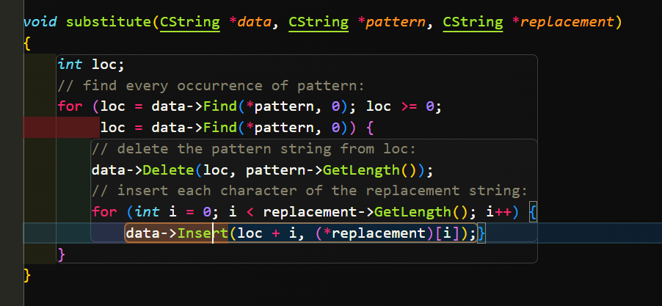
改为：
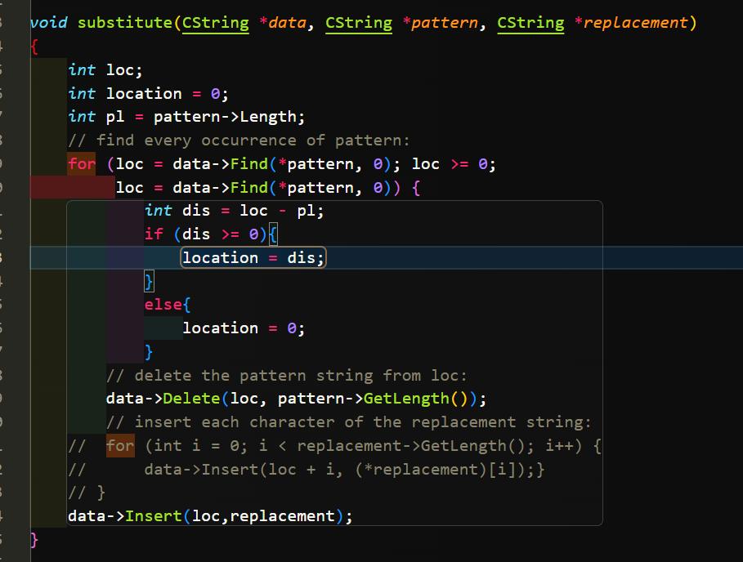

//这次的实验我也看不懂，随便写写😇

